**REPORT**

**LAB 1: I am Rich**

**Student name: Trần Quang Trình**

**Student ID: 21IT456**

**Student email:** [**trinhtq.21it@vku.udn.vn**](mailto:trinhtq.21it@vku.udn.vn)

1. **Introduction**

* Briefly describe the purpose of the lab report: This is an experiment to get acquainted with cross-platform mobile application development.
* Provide background information on your mobile app: The app has a wallpaper that is a diamond placed in the center of the screen. The toolbar is located at the top, giving the design a twist.The toolbar is located at the top, giving the design a twist.

1. **Objectives**

* State the objectives of the lab: Helping students get acquainted with the multi-platform development environment; develop a basic mobile app with a custom background and a table of contents; understand the process of installing and configuring a simple app using Flutter.

1. **Methodology**

* Describe the methodology used in the lab: The method includes steps such as installing the Flutter development environment. The project structure is then created, followed by the design and implementation of the application interface. Testing is done to ensure the app displays correctly on different devices.
* Explain how your app was developed: The app is developed using Flutter, a popular framework for cross-platform mobile app development. The first step is to create a new Flutter project. The wallpaper is set as a diamond shape using the appropriate widgets, and a simple table of contents is placed at the top of the screen. The app is then tested on both Android and iOS emulators to ensure that it works as expected.

1. **Results**

* Present the results of the lab: The results of the experiment showed that the mobile application was successfully created with the desired design. The application displays a diamond-shaped background with a table of contents at the top of the page, which meets all the basic requirements set out in the experimental guide.

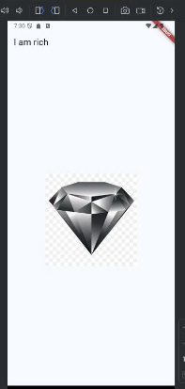 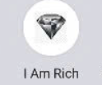

1. **Discussion**

* Discuss the results obtained: The app met the basic requirements and functioned correctly across different platforms. This indicates that the cross-platform approach using Flutter is effective for developing simple mobile applications with consistent performance.
* Analyze the strengths and weaknesses of cross-platform mobile app development: Code reusability across different platforms, reducing development time and effort; consistent user experience across multiple devices

1. **Conclusion**

* Summarize the main findings of the lab: The lab successfully introduced the basics of cross-platform mobile app development. The project demonstrated that a simple app could be created efficiently using Flutter, with a consistent design across both Android and iOS platforms.
* Provide recommendations for future work: Future work could focus on enhancing the app by adding more complex features, such as interactivity or platform-specific optimizations.